**VISVESVARAYA TECHNOLOGICAL UNIVERSITY**

**“JnanaSangama”, Belgaum -590014, Karnataka.**



**LAB REPORT**

**on**

**Artificial Intelligence (23CS5PCAIN)**

***Submitted by***

**AKSHAT KUMAR SINHA(1BM23CS021)**

***in partial fulfillment for the award of the degree of***

**BACHELOR OF ENGINEERING**

***in***

**COMPUTER SCIENCE AND ENGINEERING**



**B.M.S. COLLEGE OF ENGINEERING**

**(Autonomous Institution under VTU)**

**BENGALURU-560019**

**Aug 2025 to Dec 2025**

**B.M.S. College of Engineering,**

**Bull Temple Road, Bangalore 560019**

(Affiliated To Visvesvaraya Technological University, Belgaum)

**Department of Computer Science and Engineering**



# CERTIFICATE

This is to certify that the Lab work entitled “Artificial Intelligence (23CS5PCAIN)” carried out by **AKSHAT KUMAR SINHA(1BM23CS021),** who is bonafide student of **B.M.S. College of Engineering.** It is in partial fulfillment for the award of **Bachelor of Engineering in Computer Science and Engineering** of the Visvesvaraya Technological University, Belgaum. The Lab report has been approved as it satisfies the academic requirements in respect of an Artificial Intelligence (23CS5PCAIN) work prescribed for the said degree.

|  |  |
| --- | --- |
| Lab faculty  **Prof.Swathi Sridharan**  Assistant Professor Department of CSE, BMSCE | Dr. Kavitha Sooda Professor & HOD  Department of CSE, BMSCE |

**Index**

|  |  |  |  |
| --- | --- | --- | --- |
| **Sl.**  **No.** | **Date** | **Experiment Title** | **Page No.** |
| 1 | 30-9-2024 | Implement Tic –Tac –Toe Game Implement vacuum cleaner agent |  |
| 2 | 7-10-2024 | Implement 8 puzzle problems using Depth First Search (DFS)  Implement Iterative deepening search algorithm |  |
| 3 | 14-10-2024 | Implement A* search algorithm |  |
| 4 | 21-10-2024 | Implement Hill Climbing search algorithm to solve N-Queens problem |  |
| 5 | 28-10-2024 | Simulated Annealing to Solve 8-Queens problem |  |
| 6 | 11-11-2024 | Create a knowledge base using propositional logic and show that the given query entails the knowledge base or not. |  |
| 7 | 2-12-2024 | Implement unification in first order logic |  |
| 8 | 2-12-2024 | Create a knowledge base consisting of first order logic statements and prove the given query using forward reasoning. |  |
| 9 | 16-12-2024 | Create a knowledge base consisting of first order logic statements and prove the given query using Resolution |  |
| 10 | 16-12-2024 | Implement Alpha-Beta Pruning. |  |

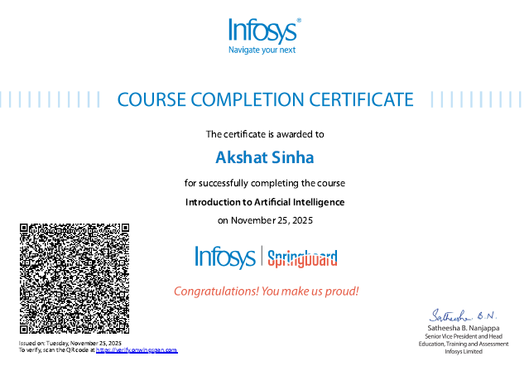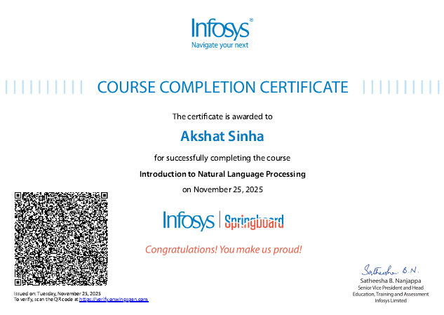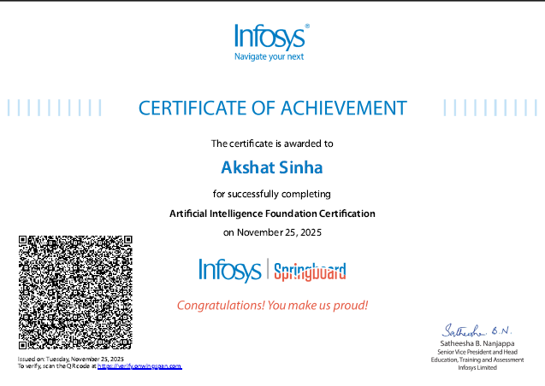

**Github Link:** https://github.com/akshat22484/Ai-lab

# Program 1

Implement Tic –Tac –Toe Game Implement vacuum cleaner agent

# Algorithm:

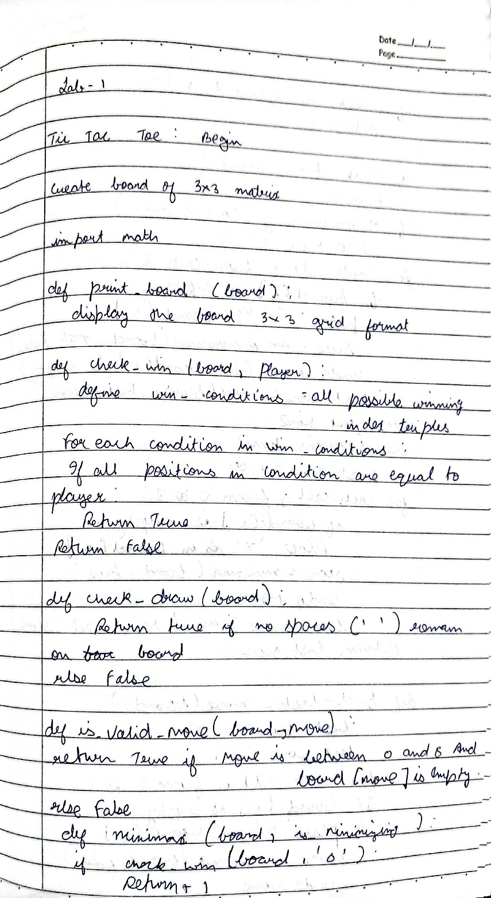

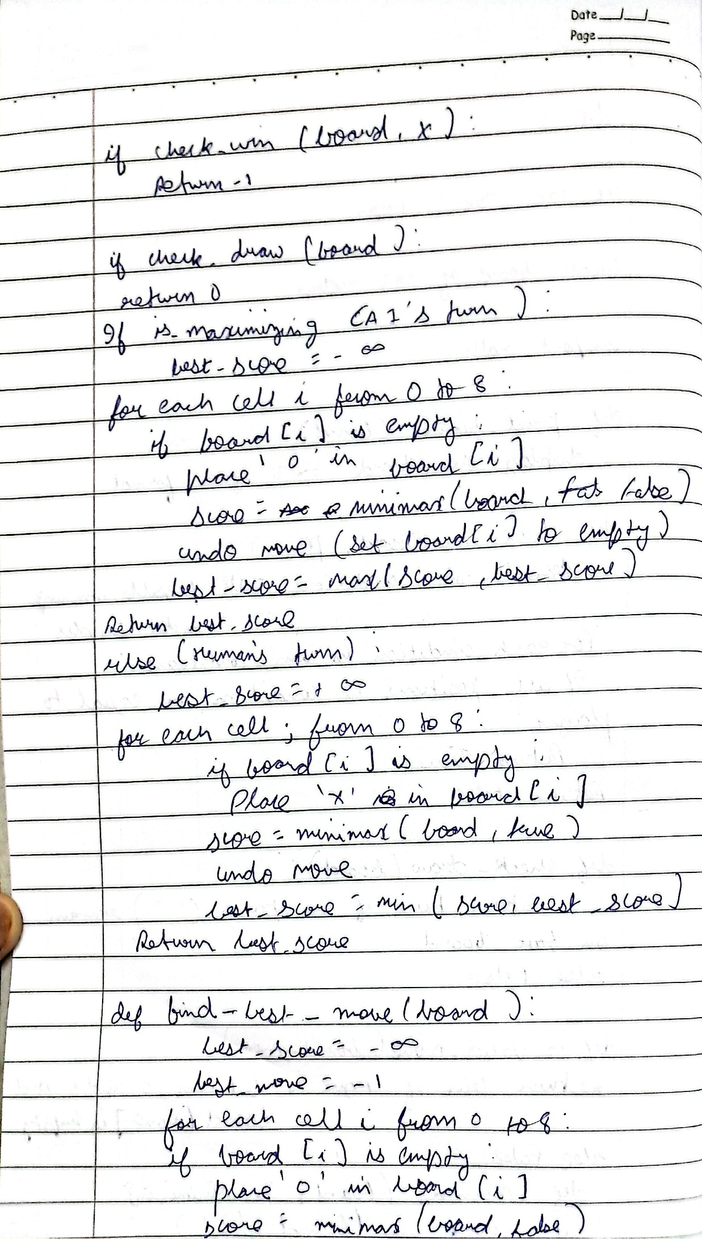

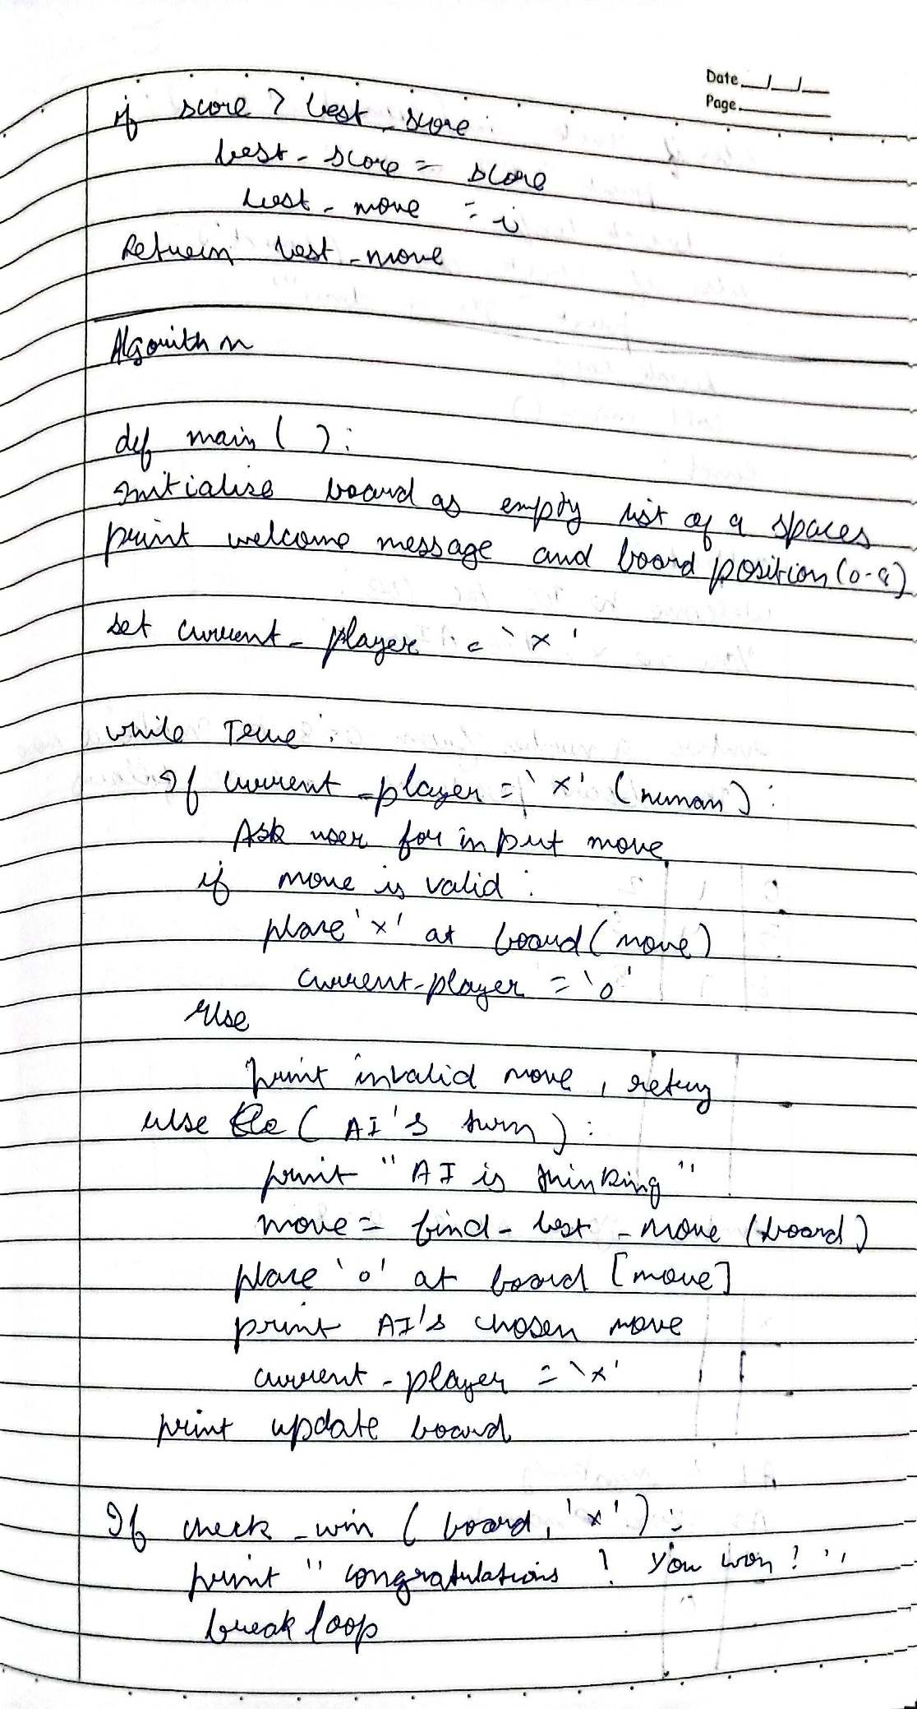**Code:**

def print_board(board): for row in board:

print(" ".join(row)) print()

def check_winner(board, player): for i in range(3):

if all(board[i][j] == player for j in range(3)): return True if all(board[j][i] == player for j in range(3)): return True if all(board[i][i] == player for i in range(3)): return True

if all(board[i][2 - i] == player for i in range(3)): return True return False

def is_draw(board):

return all(board[i][j] != '-' for i in range(3) for j in range(3))

def minimax(board, is_ai_turn):

if check_winner(board, 'O'): # AI win return 1

if check_winner(board, 'X'): # Player win return -1 if is_draw(board):

return 0

if is_ai_turn:

best_score = -float('inf') for i in range(3):

for j in range(3):

if board[i][j] == '-':

board[i][j] = 'O'

score = minimax(board, False) board[i][j] = '-' best_score = max(score, best_score) return best_score else:

best_score = float('inf') for i in range(3):

for j in range(3):

if board[i][j] == '-':

board[i][j] = 'X'

score = minimax(board, True) board[i][j] = '-' best_score = min(score, best_score) return best_score

def manual_game():

board = [['-' for _ in range(3)] for _ in range(3)] print("Initial Board:") print_board(board)

while True:

# Input X move while True:

try:

x_row = int(input("Enter X row (1-3): ")) - 1 x_col = int(input("Enter X col (1-3): ")) - 1 if board[x_row][x_col] == '-': board[x_row][x_col] = 'X' break

else:

print("Cell occupied!") except:

print("Invalid input!")

print("Board after X move:") print_board(board) if check_winner(board, 'X'):

print("X wins!") break if is_draw(board):

print("Draw!") break

# Input O move while True:

try:

o_row = int(input("Enter O row (1-3): ")) - 1 o_col = int(input("Enter O col (1-3): ")) - 1

if board[o_row][o_col] == '-': board[o_row][o_col] = 'O' break else:

print("Cell occupied!") except:

print("Invalid input!")

print("Board after O move:") print_board(board) if check_winner(board, 'O'): print("O wins!") break

if is_draw(board):

print("Draw!") break

# AI evaluates the board (from current position)

cost = minimax(board, True) # AI's turn to move next print(f"AI evaluation cost from this position: {cost}") manual_game()

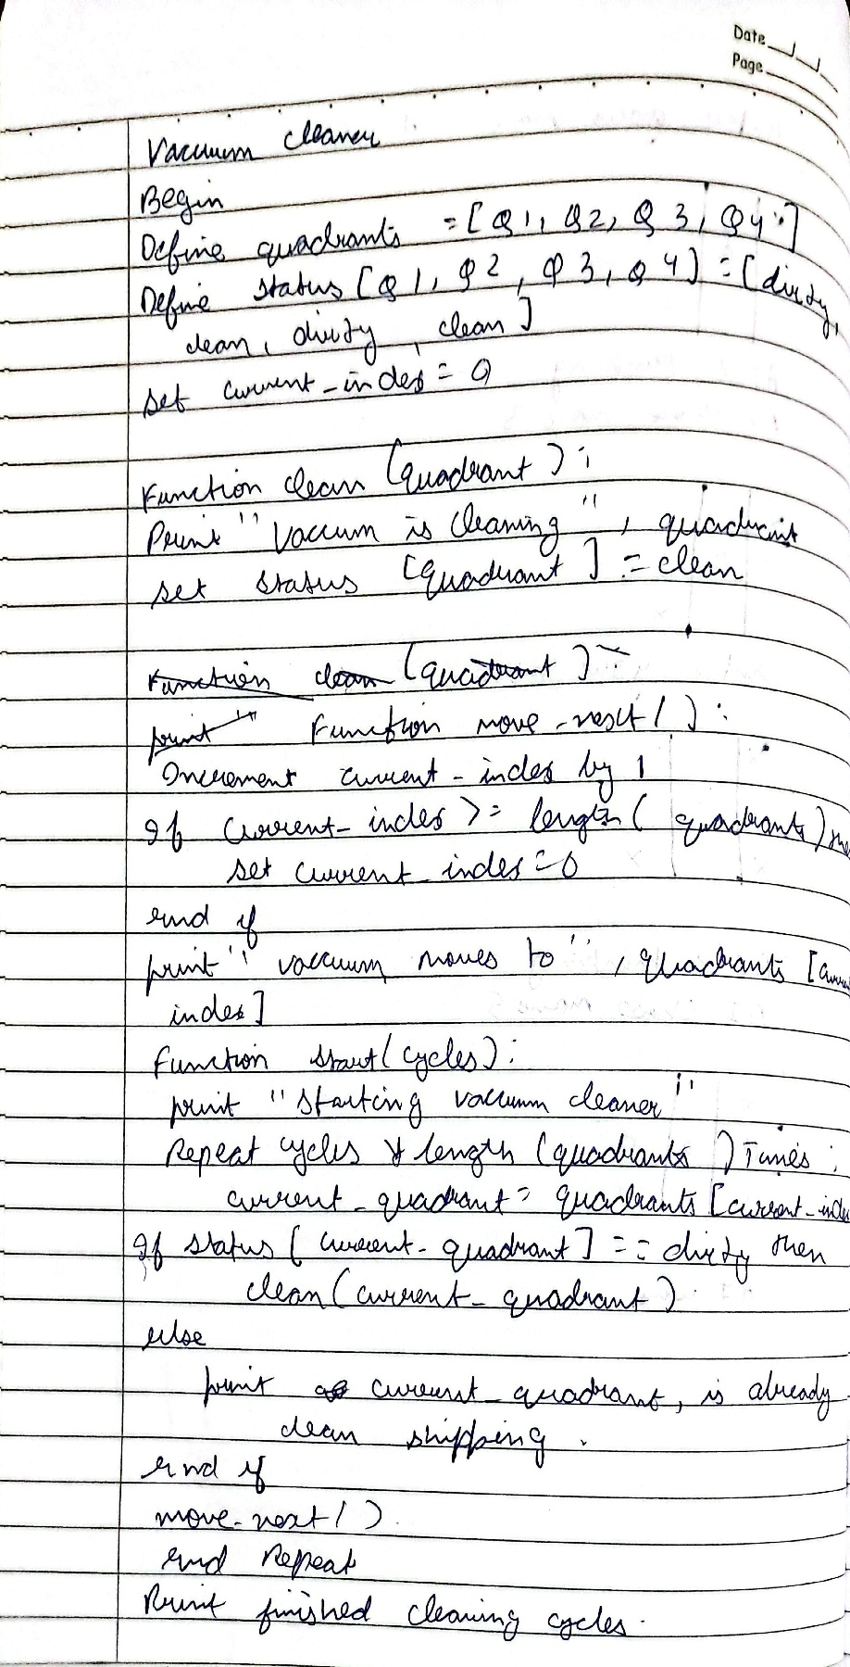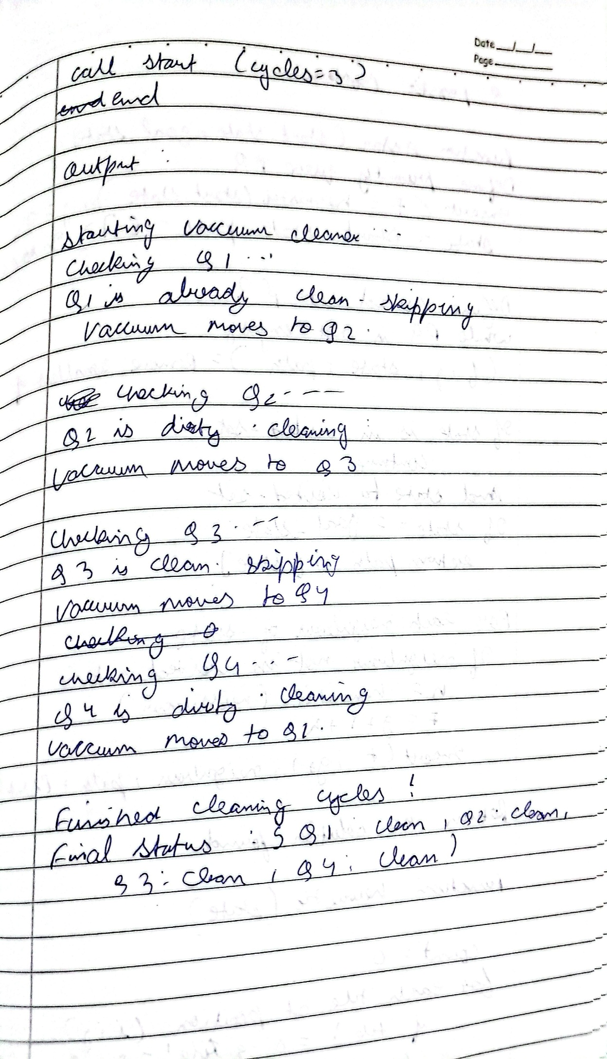

# Code:

def vacuum_cleaner():

# Taking user input for the state of each room

state_A = int(input("Enter state of A (0 for clean, 1 for dirty): ")) state_B = int(input("Enter state of B (0 for clean, 1 for dirty): ")) state_C = int(input("Enter state of C (0 for clean, 1 for dirty): ")) state_D = int(input("Enter state of D (0 for clean, 1 for dirty): ")) location = input("Enter location (A, B, C, or D): ").upper()

cost = 0

rooms = {'A': state_A, 'B': state_B, 'C': state_C, 'D': state_D}

# Function to clean a room and update the cost def clean_room(room): nonlocal cost

if rooms[room] == 1: print(f"Cleaned {room}.") rooms[room] = 0 cost += 1 else:

print(f"{room} is clean.")

if location == 'A': clean_room('A') print("Moving vacuum right") clean_room('B')

print("Moving vacuum down") clean_room('D') print("Moving vacuum left") clean_room('C')

elif location == 'B': clean_room('B') print("Moving vacuum left") clean_room('A')

print("Moving vacuum down") clean_room('D') print("Moving vacuum right") clean_room('C')

elif location == 'C': clean_room('C') print("Moving vacuum right") clean_room('D')

print("Moving vacuum up") clean_room('B') print("Moving vacuum left") clean_room('A')

elif location == 'D': clean_room('D') print("Moving vacuum up") clean_room('B')

print("Moving vacuum right")

clean_room('C') print("Moving vacuum left") clean_room('A')

else:

print("Invalid starting location!")

print(f"Cost: {cost}") print("Room states:", rooms)

# Program 2

Implement 8 puzzle problems using Depth First Search (DFS) Implement Iterative deepening search algorithm

# Algorithm:

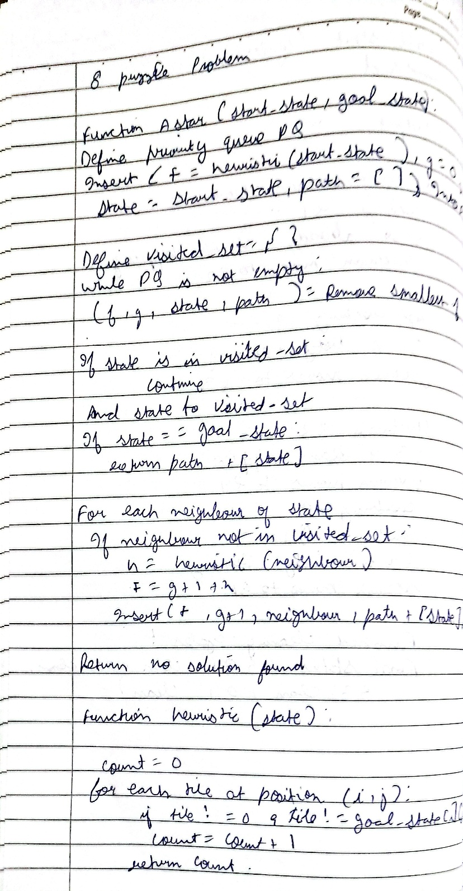

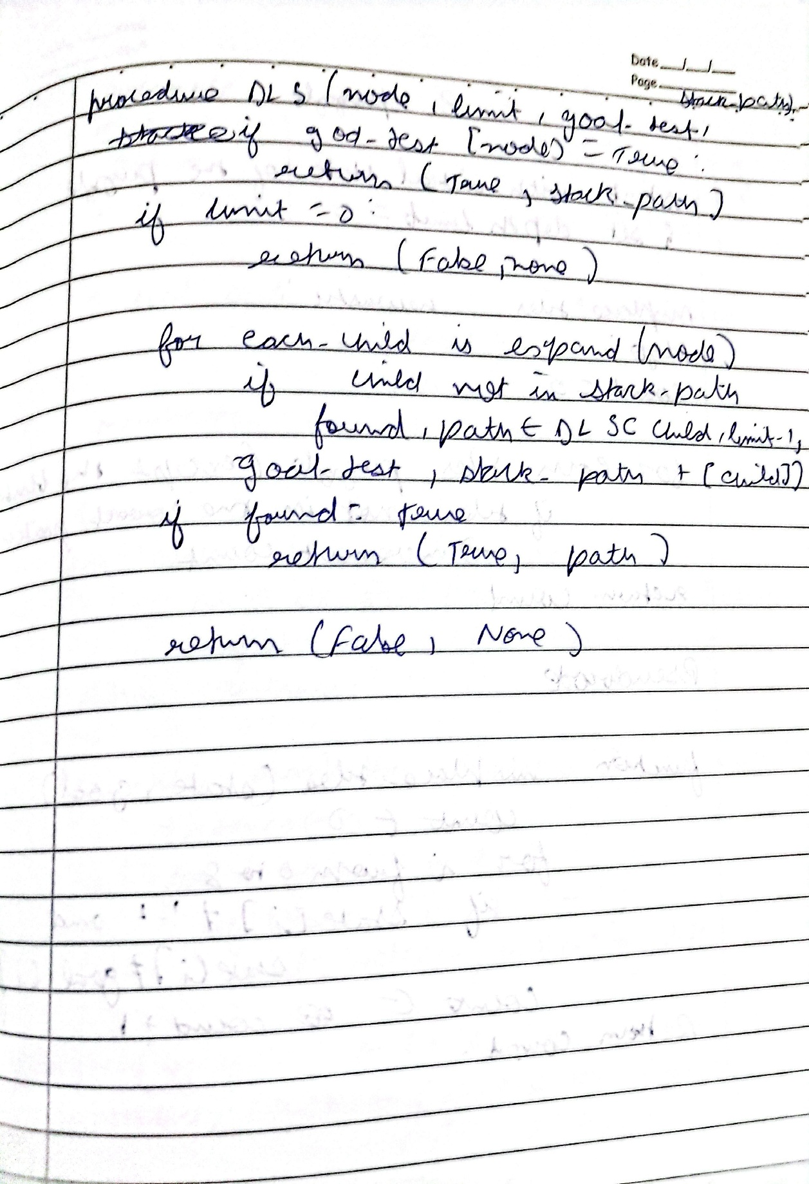

**Code:**

from collections import deque def find_blank(state):

"""Finds the position of the blank tile (0).""" for i in range(3): for j in range(3):

if state[i][j] == 0: return (i, j)def get_neighbors(state):

"""Generates all possible next states from the current state.""" neighbors = [] blank_row, blank_col = find_blank(state)

moves = [(0, 1), (0, -1), (1, 0), (-1, 0)] # Right, Left, Down, Up

for move_row, move_col in moves:

new_row, new_col = blank_row + move_row, blank_col + move_col

if 0 <= new_row < 3 and 0_state = ( (1, 2, 3),

(4, 0, 5),

(6, 7, 8)

)

goal_state = ( (1, 2, 3),

(4, 5, 6),

(7, 8, 0)

)

solution_path = dfs(initial_state, goal_state) if solution_path: print("Solution Found!")

for i, state in enumerate(solution_path): print(f"Step {i+1}:") for row in state: print(row)

print("-" * 10) else: print("No solution exists.")

# Program 3

Implement A* search algorithm

# Algorithm:

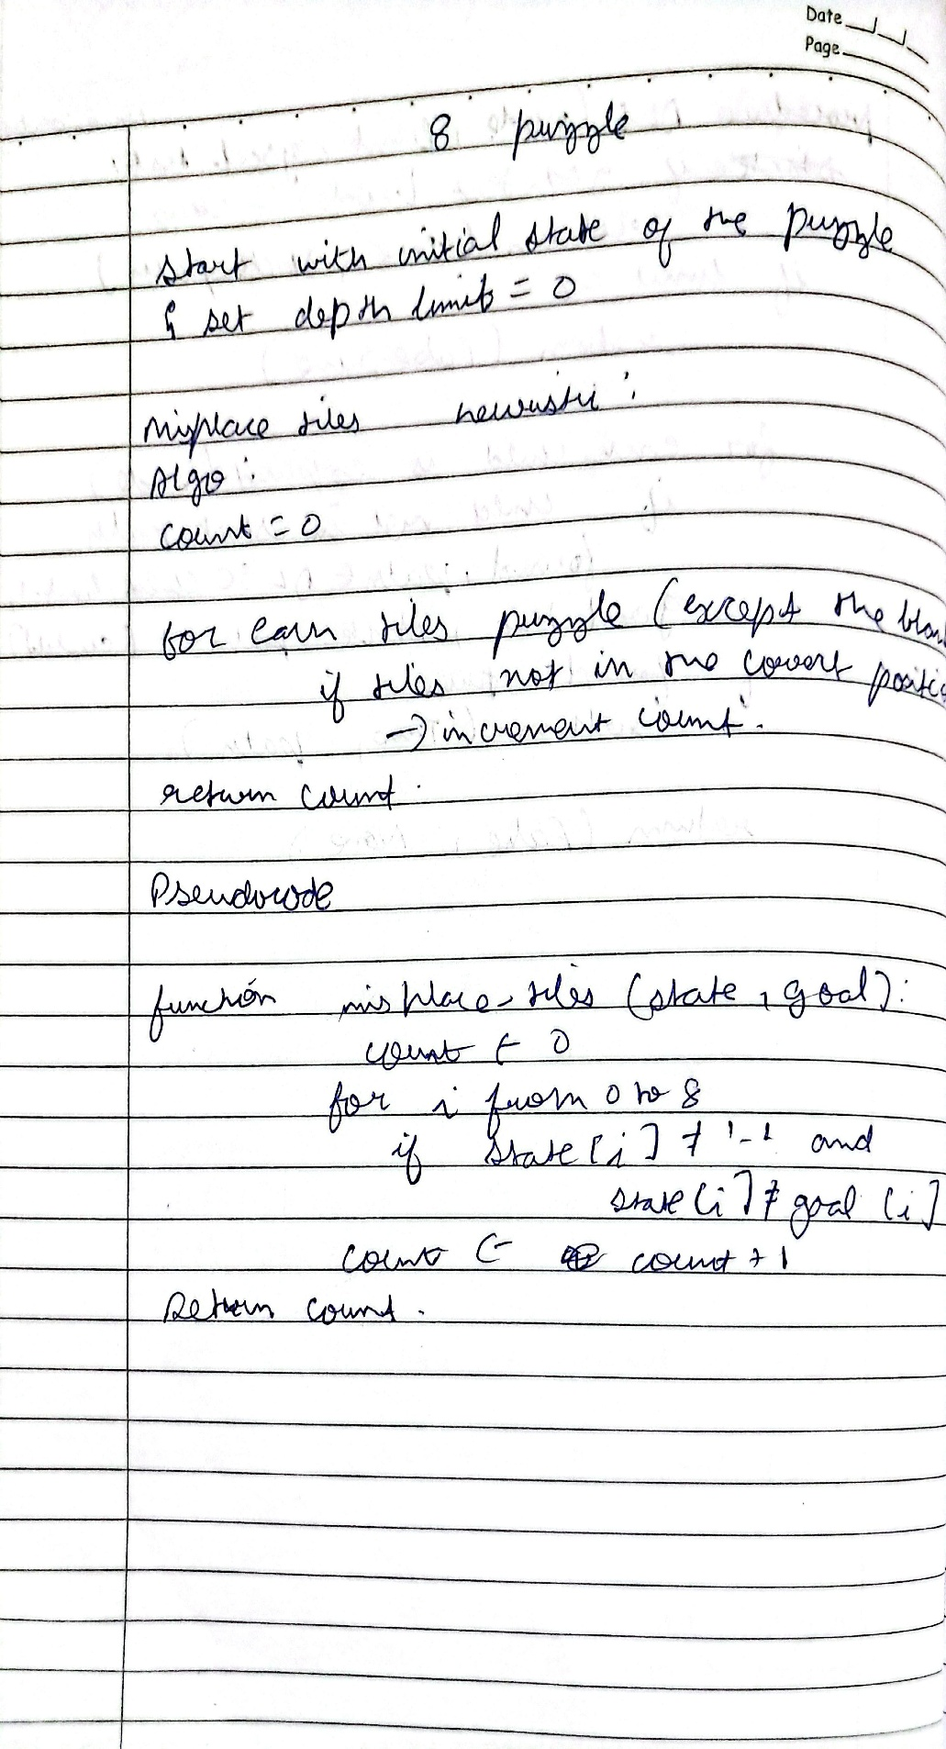

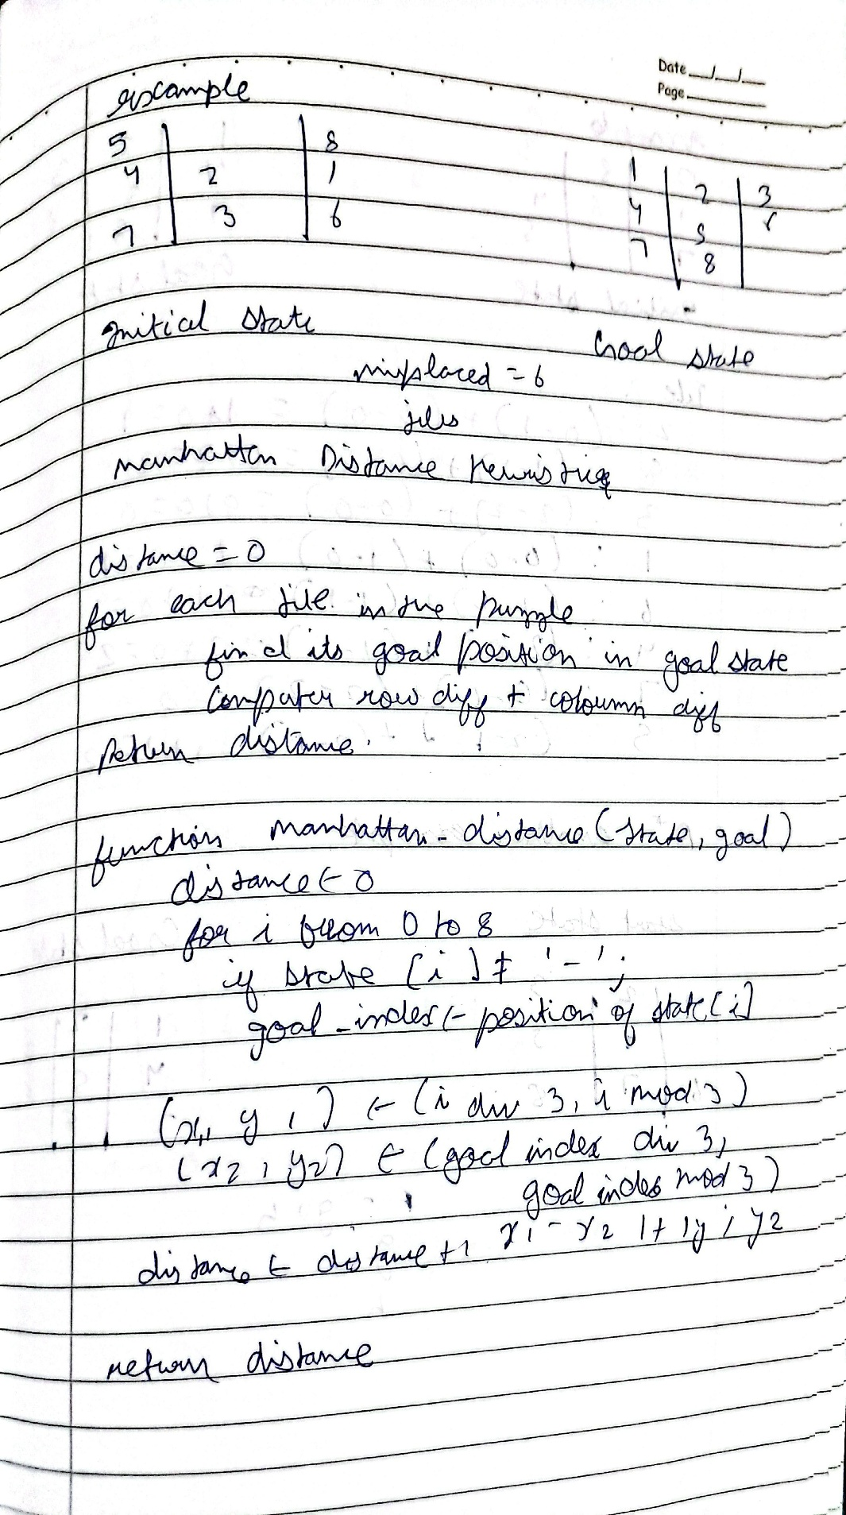

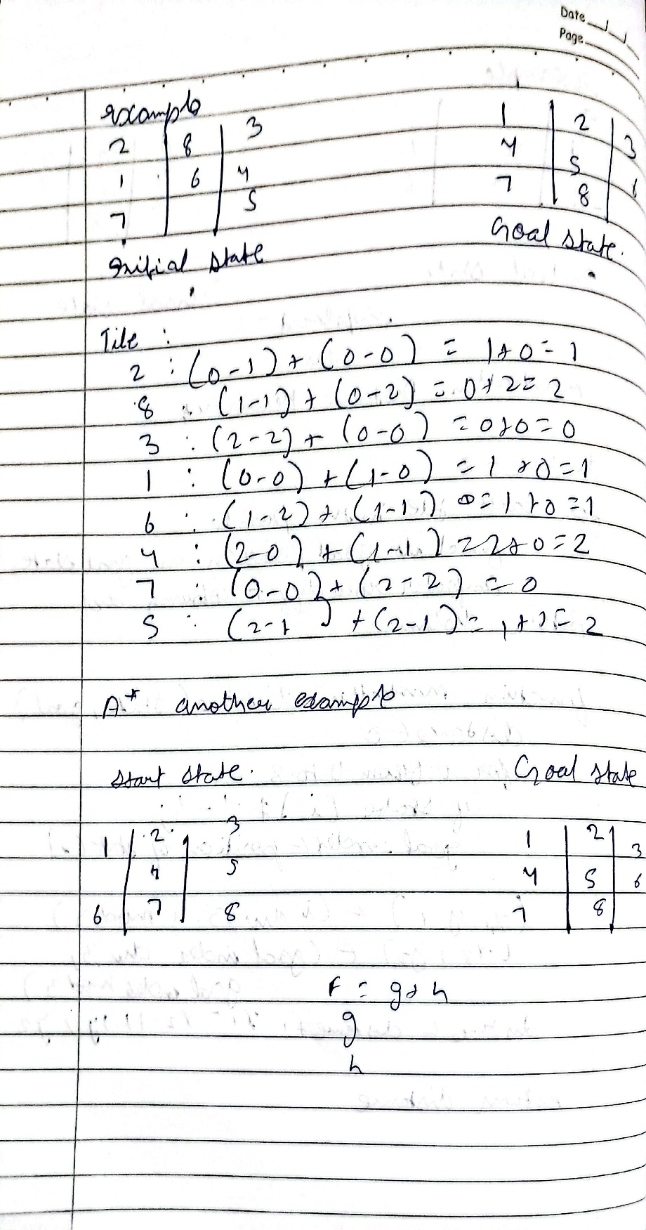

**Code:**

import heapq

def manhattan_distance(state, goal): distance = 0 for i in range(3): for j in range(3):

if state[i][j] != 0: value = state[i][j]

# Find the position of the value in the goal state for gi in range(3):

for gj in range(3):

if goal[gi][gj] == value: goal_pos = (gi, gj) break else:

continue break

distance += abs(i - goal_pos[0]) + abs(j - goal_pos[1]) return distance

def get_neighbors(state): neighbors = [] for i in range(3): for j in range(3):

if state[i][j] == 0: x, y = i, j break else:

continue break

moves = [(0, 1), (0, -1), (1, 0), (-1, 0)]

for dx, dy in moves:

nx, ny = x + dx, y + dy

if 0 <= nx < 3 and 0 <= ny < 3:

new_state = [list(row) for row in state]

new_state[x][y], new_state[nx][ny] = new_state[nx][ny], new_state[x][y] neighbors.append(tuple(tuple(row) for row in new_state))

return neighbors

def astar_search_manhattan(initial, goal):

frontier = [(manhattan_distance(initial, goal), 0, initial)] explored = set() parent = {}

cost = {initial: 0}

while frontier:

f, g, current = heapq.heappop(frontier)

if current == goal: path = []

while current in parent: path.append(current) current = parent[current] path.append(initial) return path[::-1]

explored.add(current)

for neighbor in get_neighbors(current): new_cost = cost[current] + 1

if neighbor not in cost or new_cost < cost[neighbor]: cost[neighbor] = new_cost

priority = new_cost + manhattan_distance(neighbor, goal) heapq.heappush(frontier, (priority, new_cost, neighbor)) parent[neighbor] = current

return None

def get_state_input(prompt): print(prompt) state = []

for _ in range(3):

row = list(map(int, input().split()))

state.append(row)

return tuple(tuple(row) for row in state)

initial_state_m = get_state_input("Enter the initial state for Manhattan distance (3 rows of 3 numbers separated by spaces, use 0 for the blank):")

goal_state_m = get_state_input("Enter the goal state for Manhattan distance (3 rows of 3 numbers separated by spaces, use 0 for the blank):")

path_m = astar_search_manhattan(initial_state_m, goal_state_m) if path_m: print("Solution found using Manhattan distance:")

for step in path_m: for row in step:

print(row) print() else:

print("No solution found using Manhattan distance.")

# Program 4

Implement Hill Climbing search algorithm to solve N-Queens problem

# Algorithm

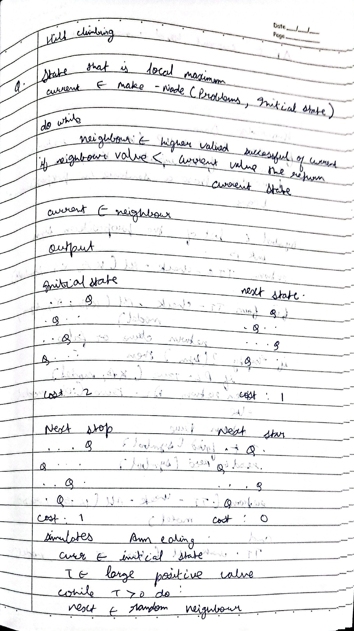

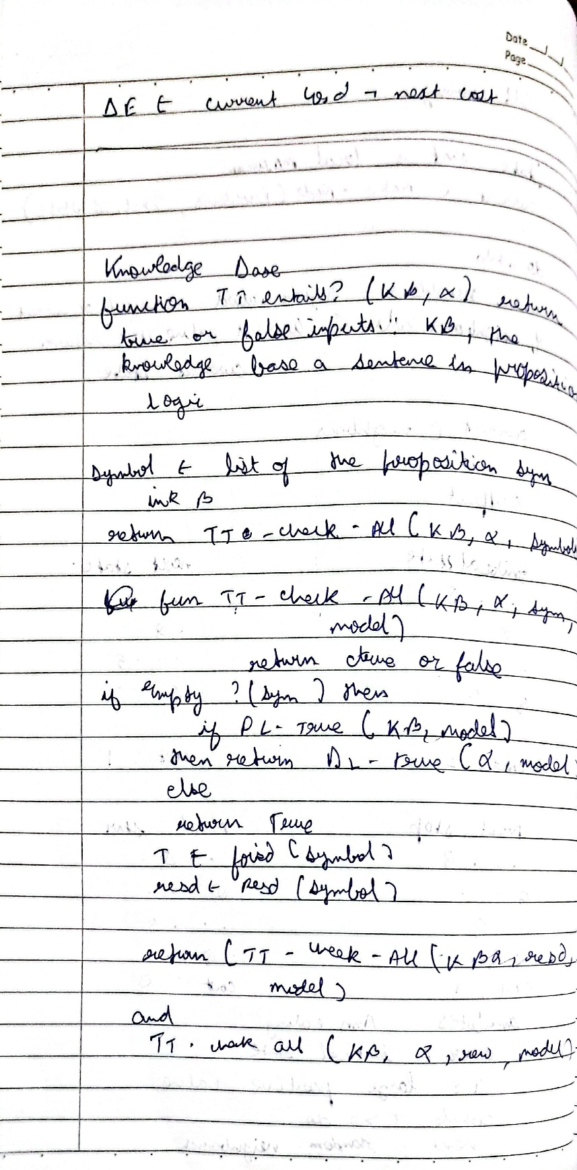

**Code:**

import random def cost(state):

attacking_pairs = 0 n = len(state) for i in range(n

for j in range(i + 1, n):

if state[i] == state[j] or abs(state[i] - state[j]) == abs(i - j):

attacking_pairs += 1 return attacking_pairs

def print_board(state):

n = len(state)

board = [['.' for _ in range(n)] for _ in range(n)] for i in range(n):

board[state[i]][i] = 'Q'

for row in board: print(" ".join(row)) def get_neighbors(state):

neighbors = [] n = len(state) for i in range(n):

for j in range(i + 1, n): neighbor = list(state)

neighbor[i], neighbor[j] = neighbor[j], neighbor[i] neighbors.append(tuple(neighbor)) return neighbors

def hill_climbing(initial_state):

current = initial_state print(f"Initial state:") print_board(current) print(f"Cost: {cost(current)}") print('-' * 20) while True:

neighbors = get_neighbors(current)

next_state = min(neighbors, key=lambda x: cost(x)) print(f"Next state:") print_board(next_state)

print(f"Cost: {cost(next_state)}") print('-' * 20) if cost(next_state) >= cost(current):

print(f"Solution found:") print_board(current) print(f"Cost: {cost(current)}") return current current = next_state if name == " main ":

initial_state = (3, 1, 2, 0)

# Program 5

Simulated Annealing to Solve 8-Queens problem

# Algorithm:

**Code:**

import random import math

def calculate_cost(state): cost = 0

n = len(state) for i in range(n):

for j in range(i + 1, n):

if state[i] == state[j] or abs(state[i] - state[j]) == abs(i - j): cost += 1

return cost

def get_random_neighbor(state): n = len(state)

new_state = list(state)

col = random.randint(0, n - 1) row = random.randint(0, n - 1) new_state[col] = row

return new_state

def simulated_annealing(n=8, max_iterations=10000, initial_temp=100.0, cooling_rate=0.99): current = [random.randint(0, n - 1) for _ in range(n)]

current_cost = calculate_cost(current) best = current

best_cost = current_cost temperature = initial_temp

for _ in range(max_iterations): if current_cost == 0:

break

neighbor = get_random_neighbor(current) neighbor_cost = calculate_cost(neighbor) delta = neighbor_cost - current_cost

if delta < 0 or random.random() < math.exp(-delta / temperature): current, current_cost = neighbor, neighbor_cost

if current_cost < best_cost:

best, best_cost = current, current_cost

temperature *= cooling_rate if temperature < 1e-6:

break

return best, best_cost

best_state, best_cost = simulated_annealing() print("The best position found:", best_state)

print("cost =", best_cost)

# Output:

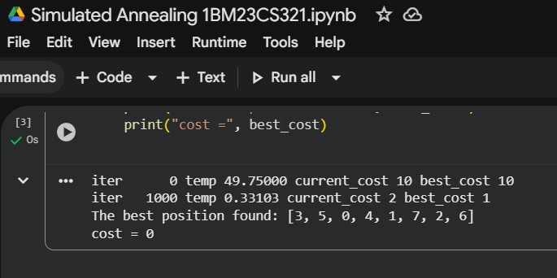

**Program 6**

Create a knowledge base using propositional logic and show that the given query entails the knowledge base or not.

# Algorithm:

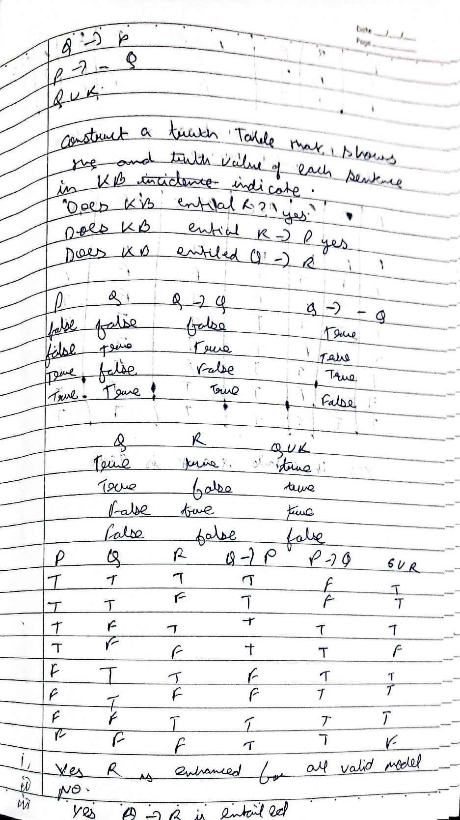

**Code:**

import itertools

def eval_expr(expr, model): try:

return eval(expr, {}, model) except:

return False

def tt_entails(KB, query):

symbols = sorted(set([ch for ch in KB + query if ch.isalpha()]))

print("\nTruth Table:")

print(" | ".join(symbols) + " | KB | Query") print("-" * (6 * len(symbols) + 20))

entails = True

for values in itertools.product([False, True], repeat=len(symbols)): model = dict(zip(symbols, values))

kb_val = eval_expr(KB, model) query_val = eval_expr(query, model)

row = " | ".join(["T" if model[s] else "F" for s in symbols]) print(f"{row} | {kb_val} | {query_val}")

if kb_val and not query_val: entails = False

return entails

KB = input("Enter Knowledge Base (use &, |, ~ for AND, OR, NOT): ") query = input("Enter Query: ")

result = tt_entails(KB, query) print("\nResult:")

if result:

print("KB entails Query (True in all cases).") else:

print("KB does NOT entail Query.")

# Output:

**Program 7**

Implement unification in first order logic

# Algorithm:

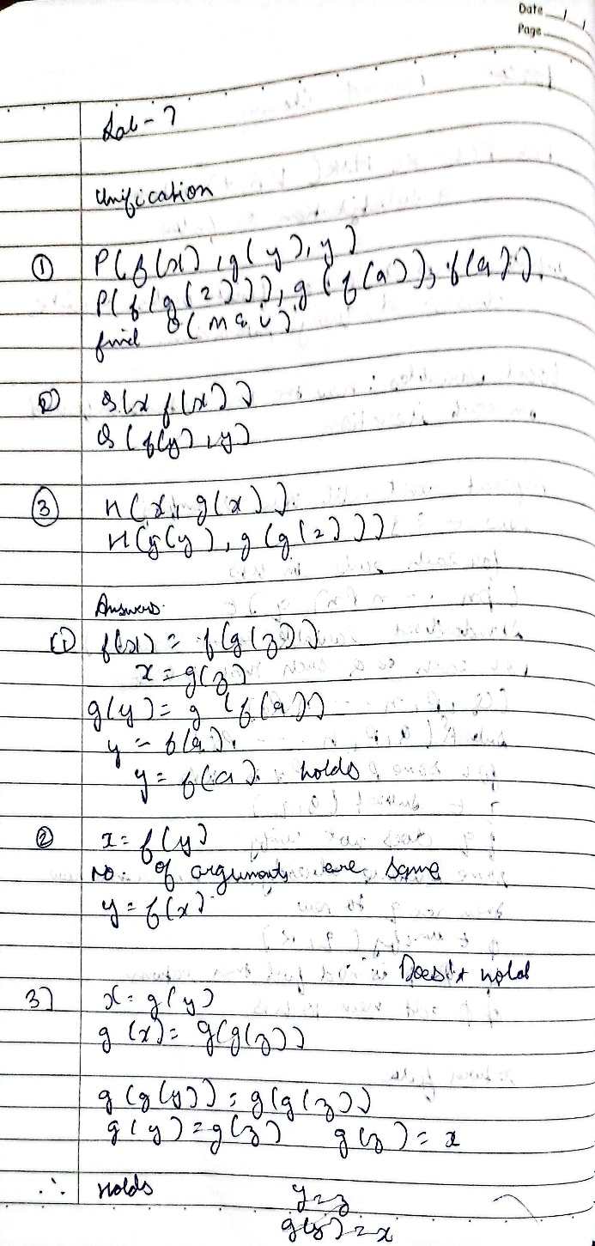

**Code:**

def occurs_check(var, term, subst): if var == term:

return True

elif isinstance(term, tuple):

return any(occurs_check(var, t, subst) for t in term) elif term in subst:

return occurs_check(var, subst[term], subst) return False

def unify(x, y, subst): if subst is None:

return None elif x == y:

return subst

elif isinstance(x, str) and x.isupper(): return unify_var(x, y, subst)

elif isinstance(y, str) and y.isupper(): return unify_var(y, x, subst)

elif isinstance(x, tuple) and isinstance(y, tuple): if x[0] != y[0] or len(x) != len(y):

return None

for a, b in zip(x[1:], y[1:]): subst = unify(a, b, subst) if subst is None:

return None return subst

else:

return None

def unify_var(var, x, subst): if var in subst:

return unify(subst[var], x, subst) elif x in subst:

return unify(var, subst[x], subst) elif occurs_check(var, x, subst):

return None else:

subst[var] = x return subst

def parse_expr(s):

s = s.replace(" ", "") if '(' not in s:

return s

name_end = s.index('(') name = s[:name_end] args = []

depth = 0 current = ""

for c in s[name_end+1:-1]: if c == ',' and depth == 0:

args.append(parse_expr(current)) current = ""

else:

if c == '(': depth += 1

elif c == ')': depth -= 1

current += c if current:

args.append(parse_expr(current)) return tuple([name] + args)

def expr_to_str(expr):

if isinstance(expr, tuple):

return expr[0] + "(" + ",".join(expr_to_str(e) for e in expr[1:]) + ")" else:

return expr

expr1_input = input("Enter first expression: ") expr2_input = input("Enter second expression: ")

expr1 = parse_expr(expr1_input) expr2 = parse_expr(expr2_input)

subst = unify(expr1, expr2, {})

if subst:

formatted_subst = {var: expr_to_str(val) for var, val in subst.items()} else:

formatted_subst = None

print("Most General Unifier (MGU):", formatted_subst)

# Output:

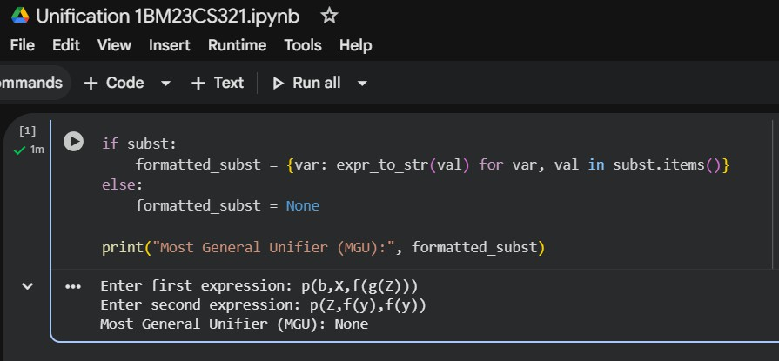

**Program 8**

Create a knowledge base consisting of first order logic statements and prove the given query using forward reasoning.

# Algorithm:

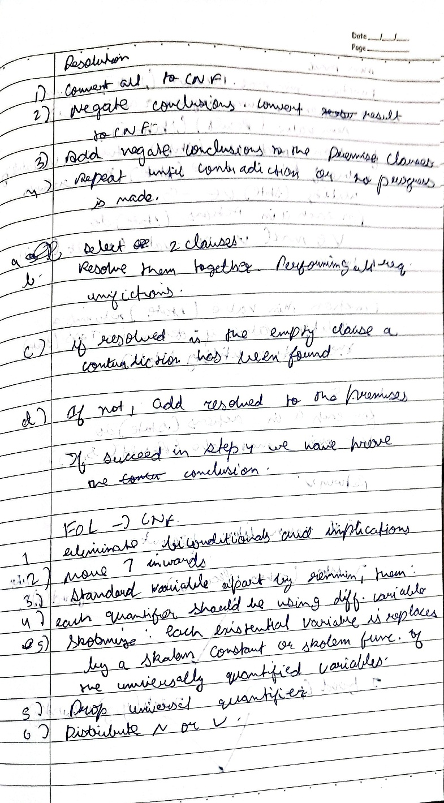

**Code:**

facts = {

'American(Robert)': True, 'Hostile(A)': True, 'Sells_Weapons(Robert, A)': True

}

If American(X) and Hostile(Y) and Sells_Weapons(X, Y), then Crime(X) def forward_reasoning(facts):

If American(X) and Hostile(Y) and Sells_Weapons(X, Y), then Crime(X)

if facts.get('American(Robert)', False) and facts.get('Hostile(A)', False) and facts.get('Sells_Weapons(Robert, A)', False):

facts['Crime(Robert)'] = True forward_reasoning(facts)

if facts.get('Crime(Robert)', False): print("Robert is a criminal.")

else:

print("Robert is not a criminal.")

# Output:

Robert is a criminal.

**Program 9**

Create a knowledge base consisting of first order logic statements and prove the given query using Resolution

# Algorithm:

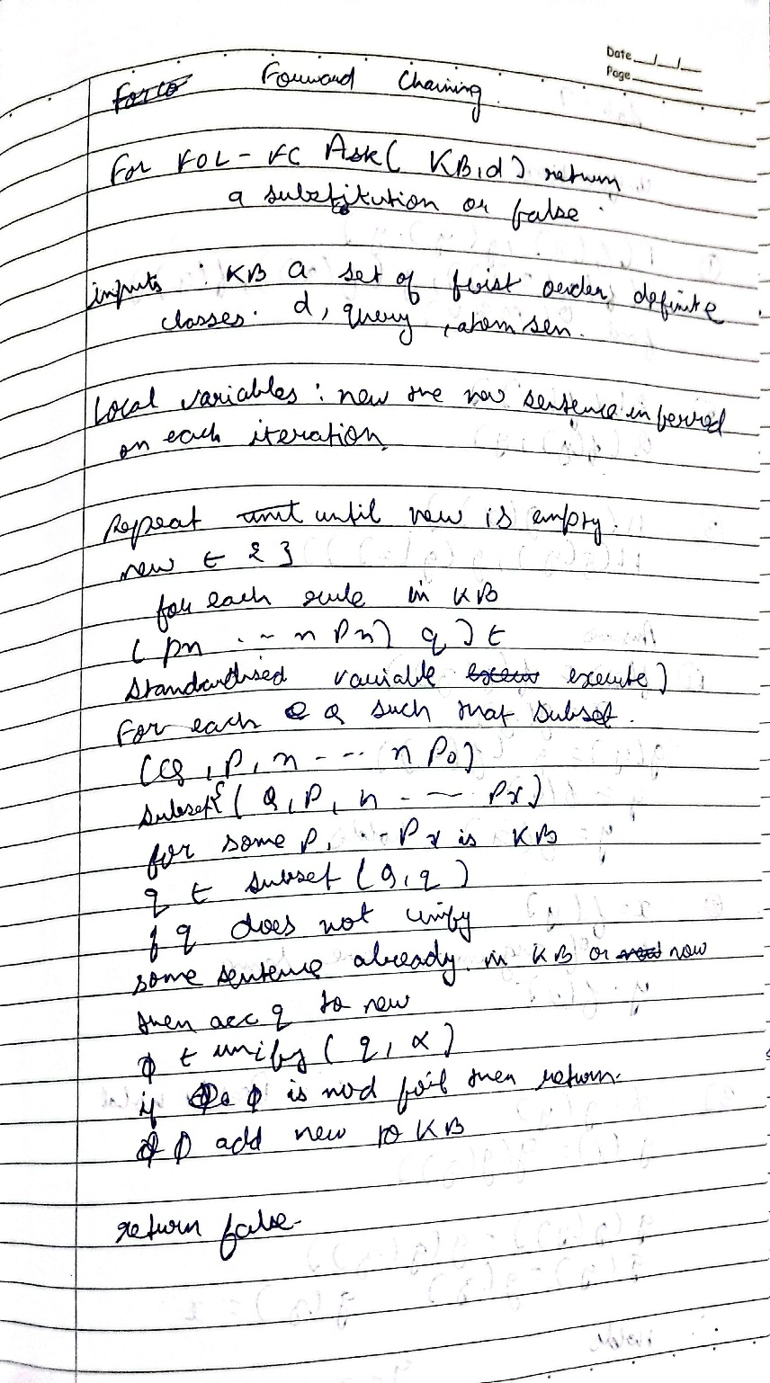

**Code:**

def fol_resolution(kb, query): print("\n" + "="*55)

print(" KNOWLEDGE BASE")

print("="*55)

for i, clause in enumerate(kb, start=1): print(f" {i}. {clause}")

print("\n" + "="*55)

print(" QUERY") print("="*55)

print(f" Prove: {query}")

print(f" Negated Query: ~{query}\n")

print("="*55)

print(" RESOLUTION PROCESS")

print("="*55)

print("Step 1: Convert all implications (→) to CNF (Conjunctive Normal Form).") print("Step 2: Eliminate all universal quantifiers (∀).")

print("Step 3: Add negated query (~Query) to the KB.") print("Step 4: Apply resolution rule between matching clauses.") print("Step 5: Continue until the empty clause (⊥) is found.\n")

print("="*55)

print(" RESOLUTION TREE")

print("="*55)

print("""

[~Likes(John, Peanuts)]

|

[Food(Peanuts) → Likes(John, Peanuts)]

|

[Eats(Anil, Peanuts) ∧ ¬Killed(Anil) → Food(Peanuts)]

|

[Alive(Anil) → ¬Killed(Anil)]

| [Alive(Anil)]

↓

⊥ (Contradiction Found)

""")

print("="*55)

print(f" Therefore, the query '{query}' is PROVEN by Resolution.") print("="*55 + "\n")

print("\n FIRST ORDER LOGIC - RESOLUTION METHOD")

n = int(input("Enter the number of statements in the Knowledge Base: ")) kb = []

print("\nEnter each statement (e.g., '∀x: Food(x) → Likes(John, x)'):")

for i in range(n):

stmt = input(f"KB[{i+1}]: ")

kb.append(stmt)

query = input("\nEnter the query to prove: ") fol_resolution(kb, query)

# Output:

**Program 10**

Implement Alpha-Beta Pruning.

# Algorithm:

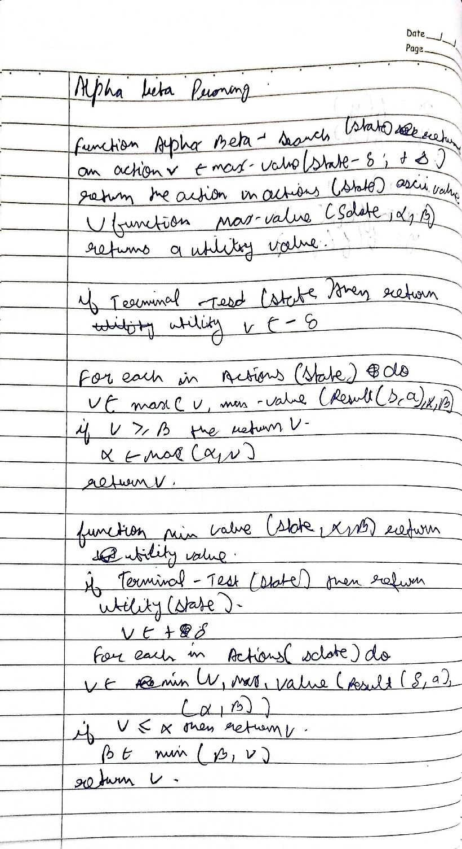

**Code:**

move_count = 0

def alpha_beta(depth, node_index, is_maximizing, values, alpha, beta, max_depth): global move_count

move_count += 1

if depth == max_depth: return values[node_index

]

if

is_maxim izing:

best = float('- inf')

for i in range(2): # binary tree

val = alpha_beta(depth + 1, node_index * 2 + i, False, values, alpha, beta, max_depth) best = max(best, val)

alpha = max(alpha, best) if beta <= alpha:

print(f" Pruned at depth {depth} on MAX node

{node_index}") break return best

else:

best = float('inf') for i in range(2):

val = alpha_beta(depth + 1, node_index * 2 + i, True, values, alpha, beta, max_depth) best = min(best, val)

beta = min(beta, best) if beta <= alpha:

print(f" Pruned at depth {depth} on MIN node

{node_index}") break return best

max_depth = int(input("Enter the maximum depth of the tree: ")) num_leaves = 2 ** max_depth

print(f"Enter {num_leaves} leaf node values separated by spaces:") values = list(map(int, input().split()))

if len(values) != num_leaves:

print(" Error: Number of values does not match 2^depth.") else:

move_count = 0

best_value = alpha_beta(0, 0, True, values, float('-inf'), float('inf'), max_depth) print("\n Best value for root (MAX):", best_value)

print(f" Total moves (nodes visited): {move_count}")

**Output:**

